

KRUPANIDHI COLLEGE OF PHARMACY
# 12/1, Chikkabellandur, Carmelaram PO, Varthur Hobli, Bengaluru 560035. Karnataka Phone: +91 90088 88415
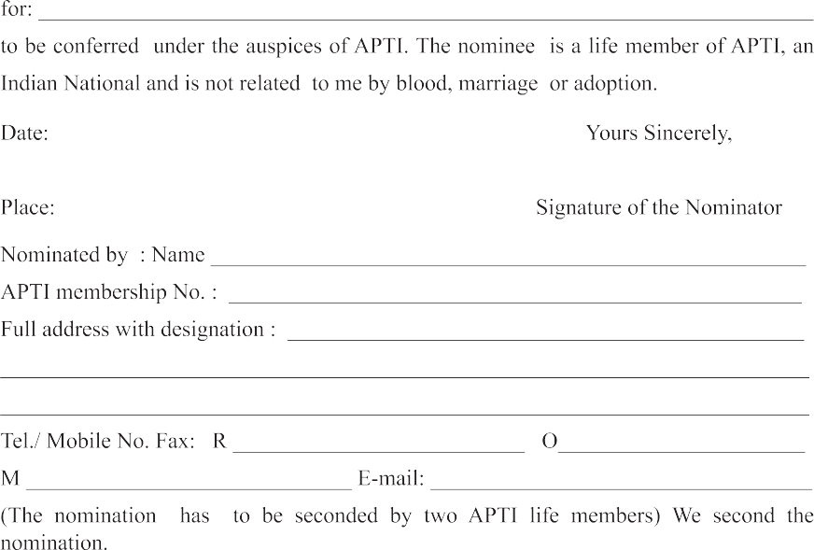
Email: aptienquiry@gmail.com





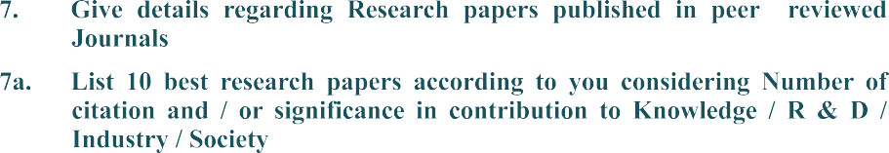







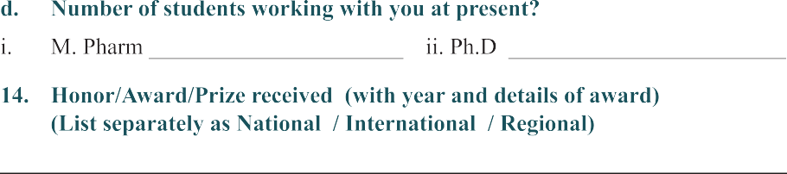

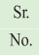





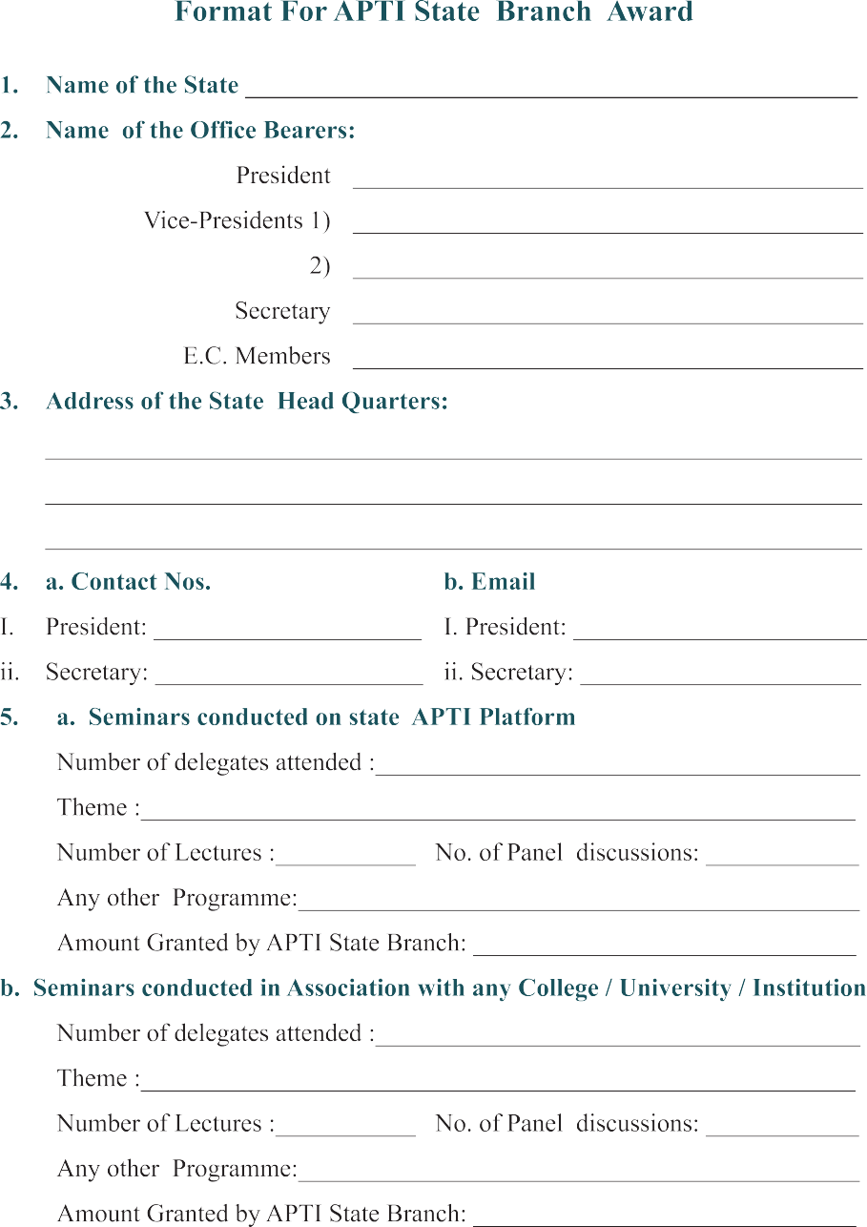

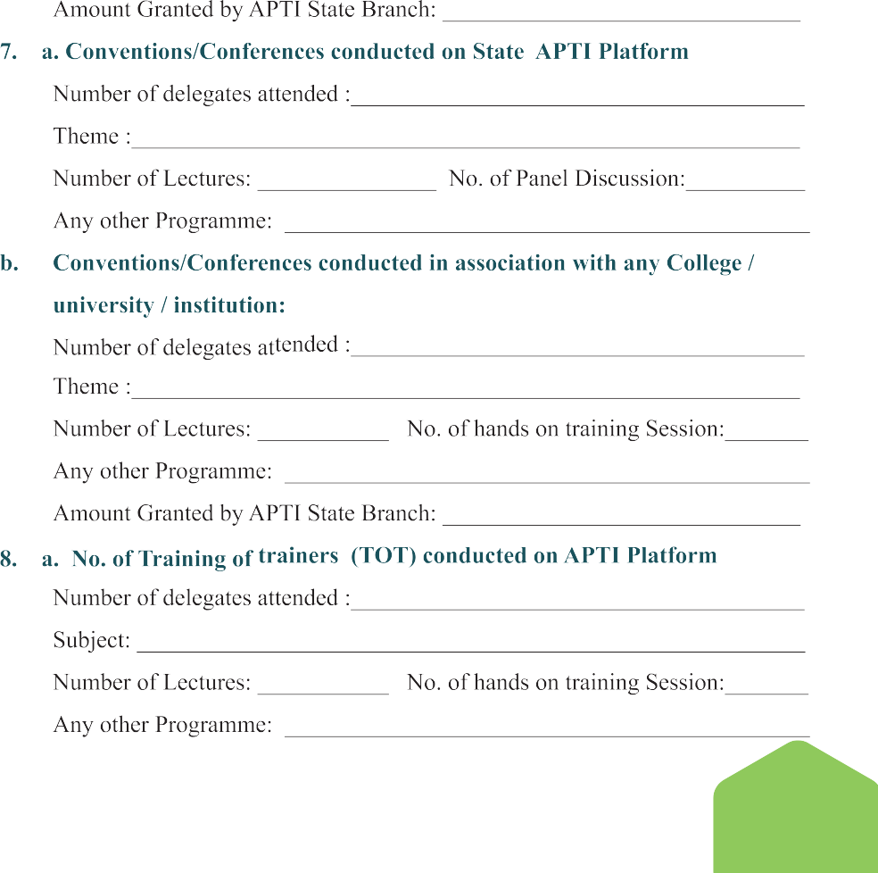

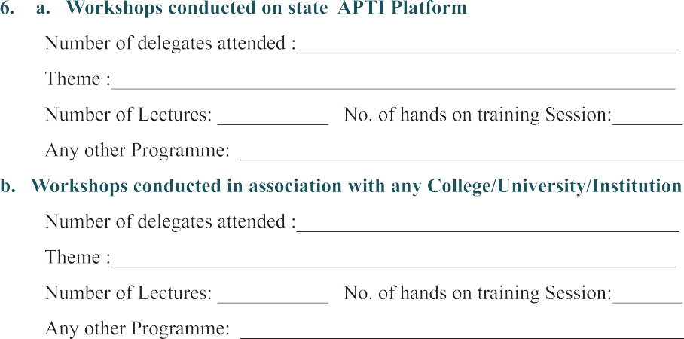

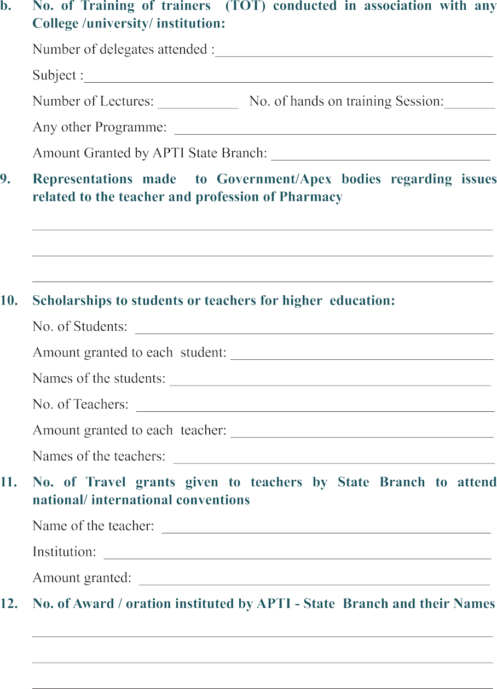

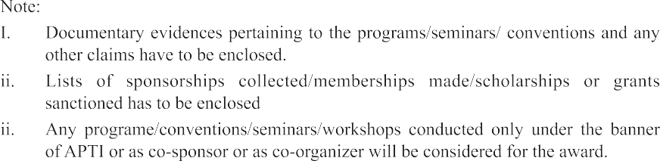

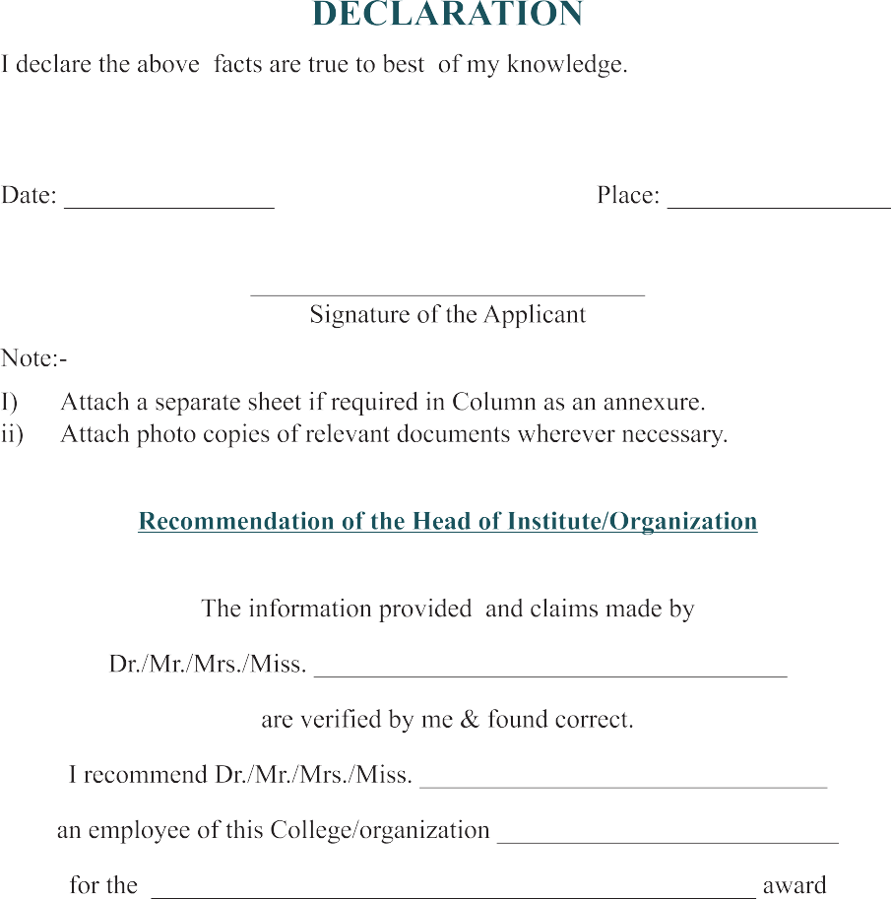



KRUPANIDHI COLLEGE OF PHARMACY
# 12/1, Chikkabellandur, Carmelaram PO, Varthur Hobli, Bengaluru 560035. Karnataka Phone: +91 90088 88415
Email: aptienquiry@gmail.com


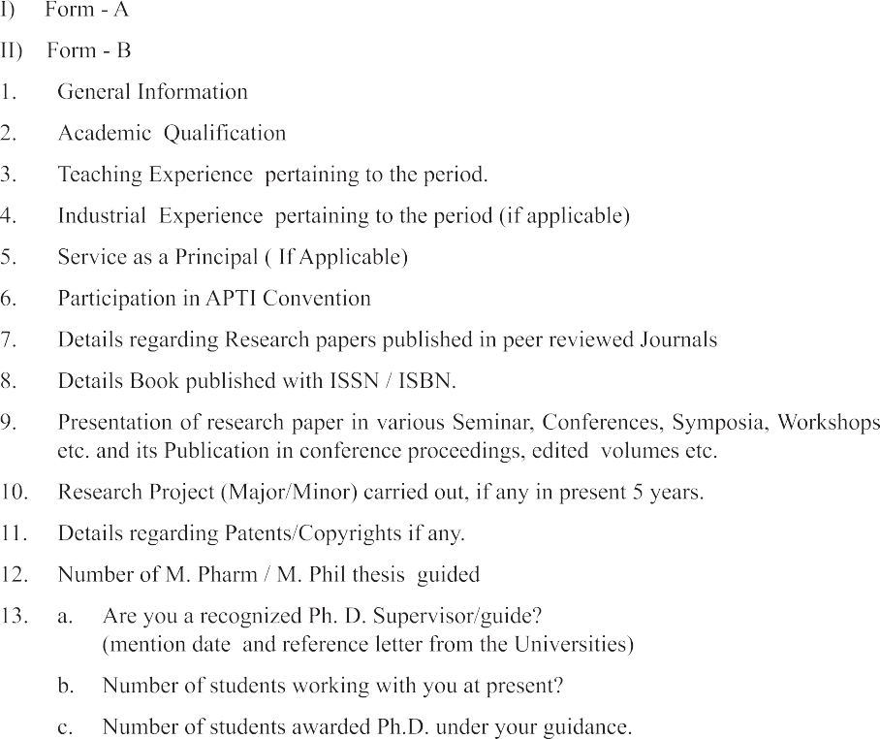
2023

